"The Shield of Achilles" is a poem by W. H. Auden first published in 1952.
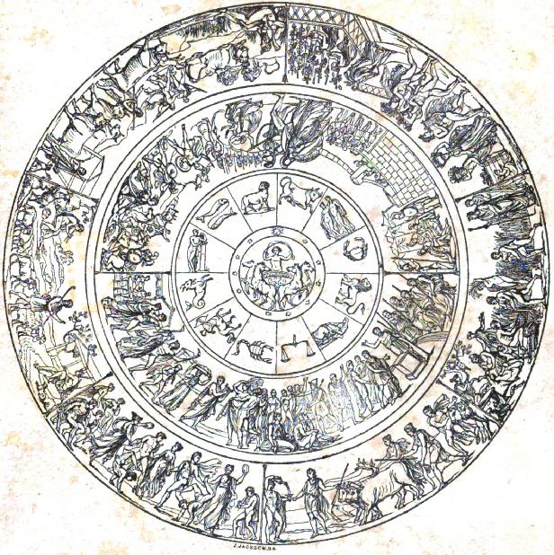
The poem is Auden's response to the detailed description, or ekphrasis, in Homer's epic poem the Iliad of the shield borne by the hero Achilles, illustrated with scenes from daily life.

Auden was disillusioned by the totalitarian state of the modern world which completely buried the growth of the individual. He felt that people existed as the 'State' and not as the 'Individual'. He therefore reflects the contrast between the modern world and the Achillean world. Auden deliberately interprets the images drawn on the shield to speak of the ills of the modern world.
Auden's poem is written in two different stanza forms, one form with shorter lines, the other with longer lines.
Thetis is repeatedly ‘dismayed’ at what she sees. She expects to see classical, traditional images of beauty, but instead sees a vision of the modern world, a disturbing world that Auden paints as becoming increasingly dehumanized. In essence, the poem is a description (or perhaps a warning) of the inevitable progression of a society that has adopted a philosophy of nihilism.
The stanzas with shorter lines describe the making of the shield by the god Hephaestus, and report the scenes that Achilles' mother, the Nereid Thetis, expects to find on the shield and which Hephaestus, in Auden's version, does not make. Thetis expects to find scenes of happiness and peace like those described by Homer.

She looked over his shoulder
For vines and olive trees,
Marble well-governed cities
And ships upon untamed seas,
But there on the shining metal
His hands had put instead
An artificial wilderness
And a sky like lead.

The stanzas with longer lines describe the scenes that Hephaestus creates in Auden's version, scenes of a barren and impersonal modern world. The poem is frequently cited as an antiwar poem, but it is also a study in language and responsibility.

A plain without a feature, bare and brown,
No blade of grass, no sign of neighborhood,
Nothing to eat and nowhere to sit down,
Yet, congregated on its blankness, stood
An unintelligible multitude,
A million eyes, a million boots in line,
Without expression, waiting for a sign.

